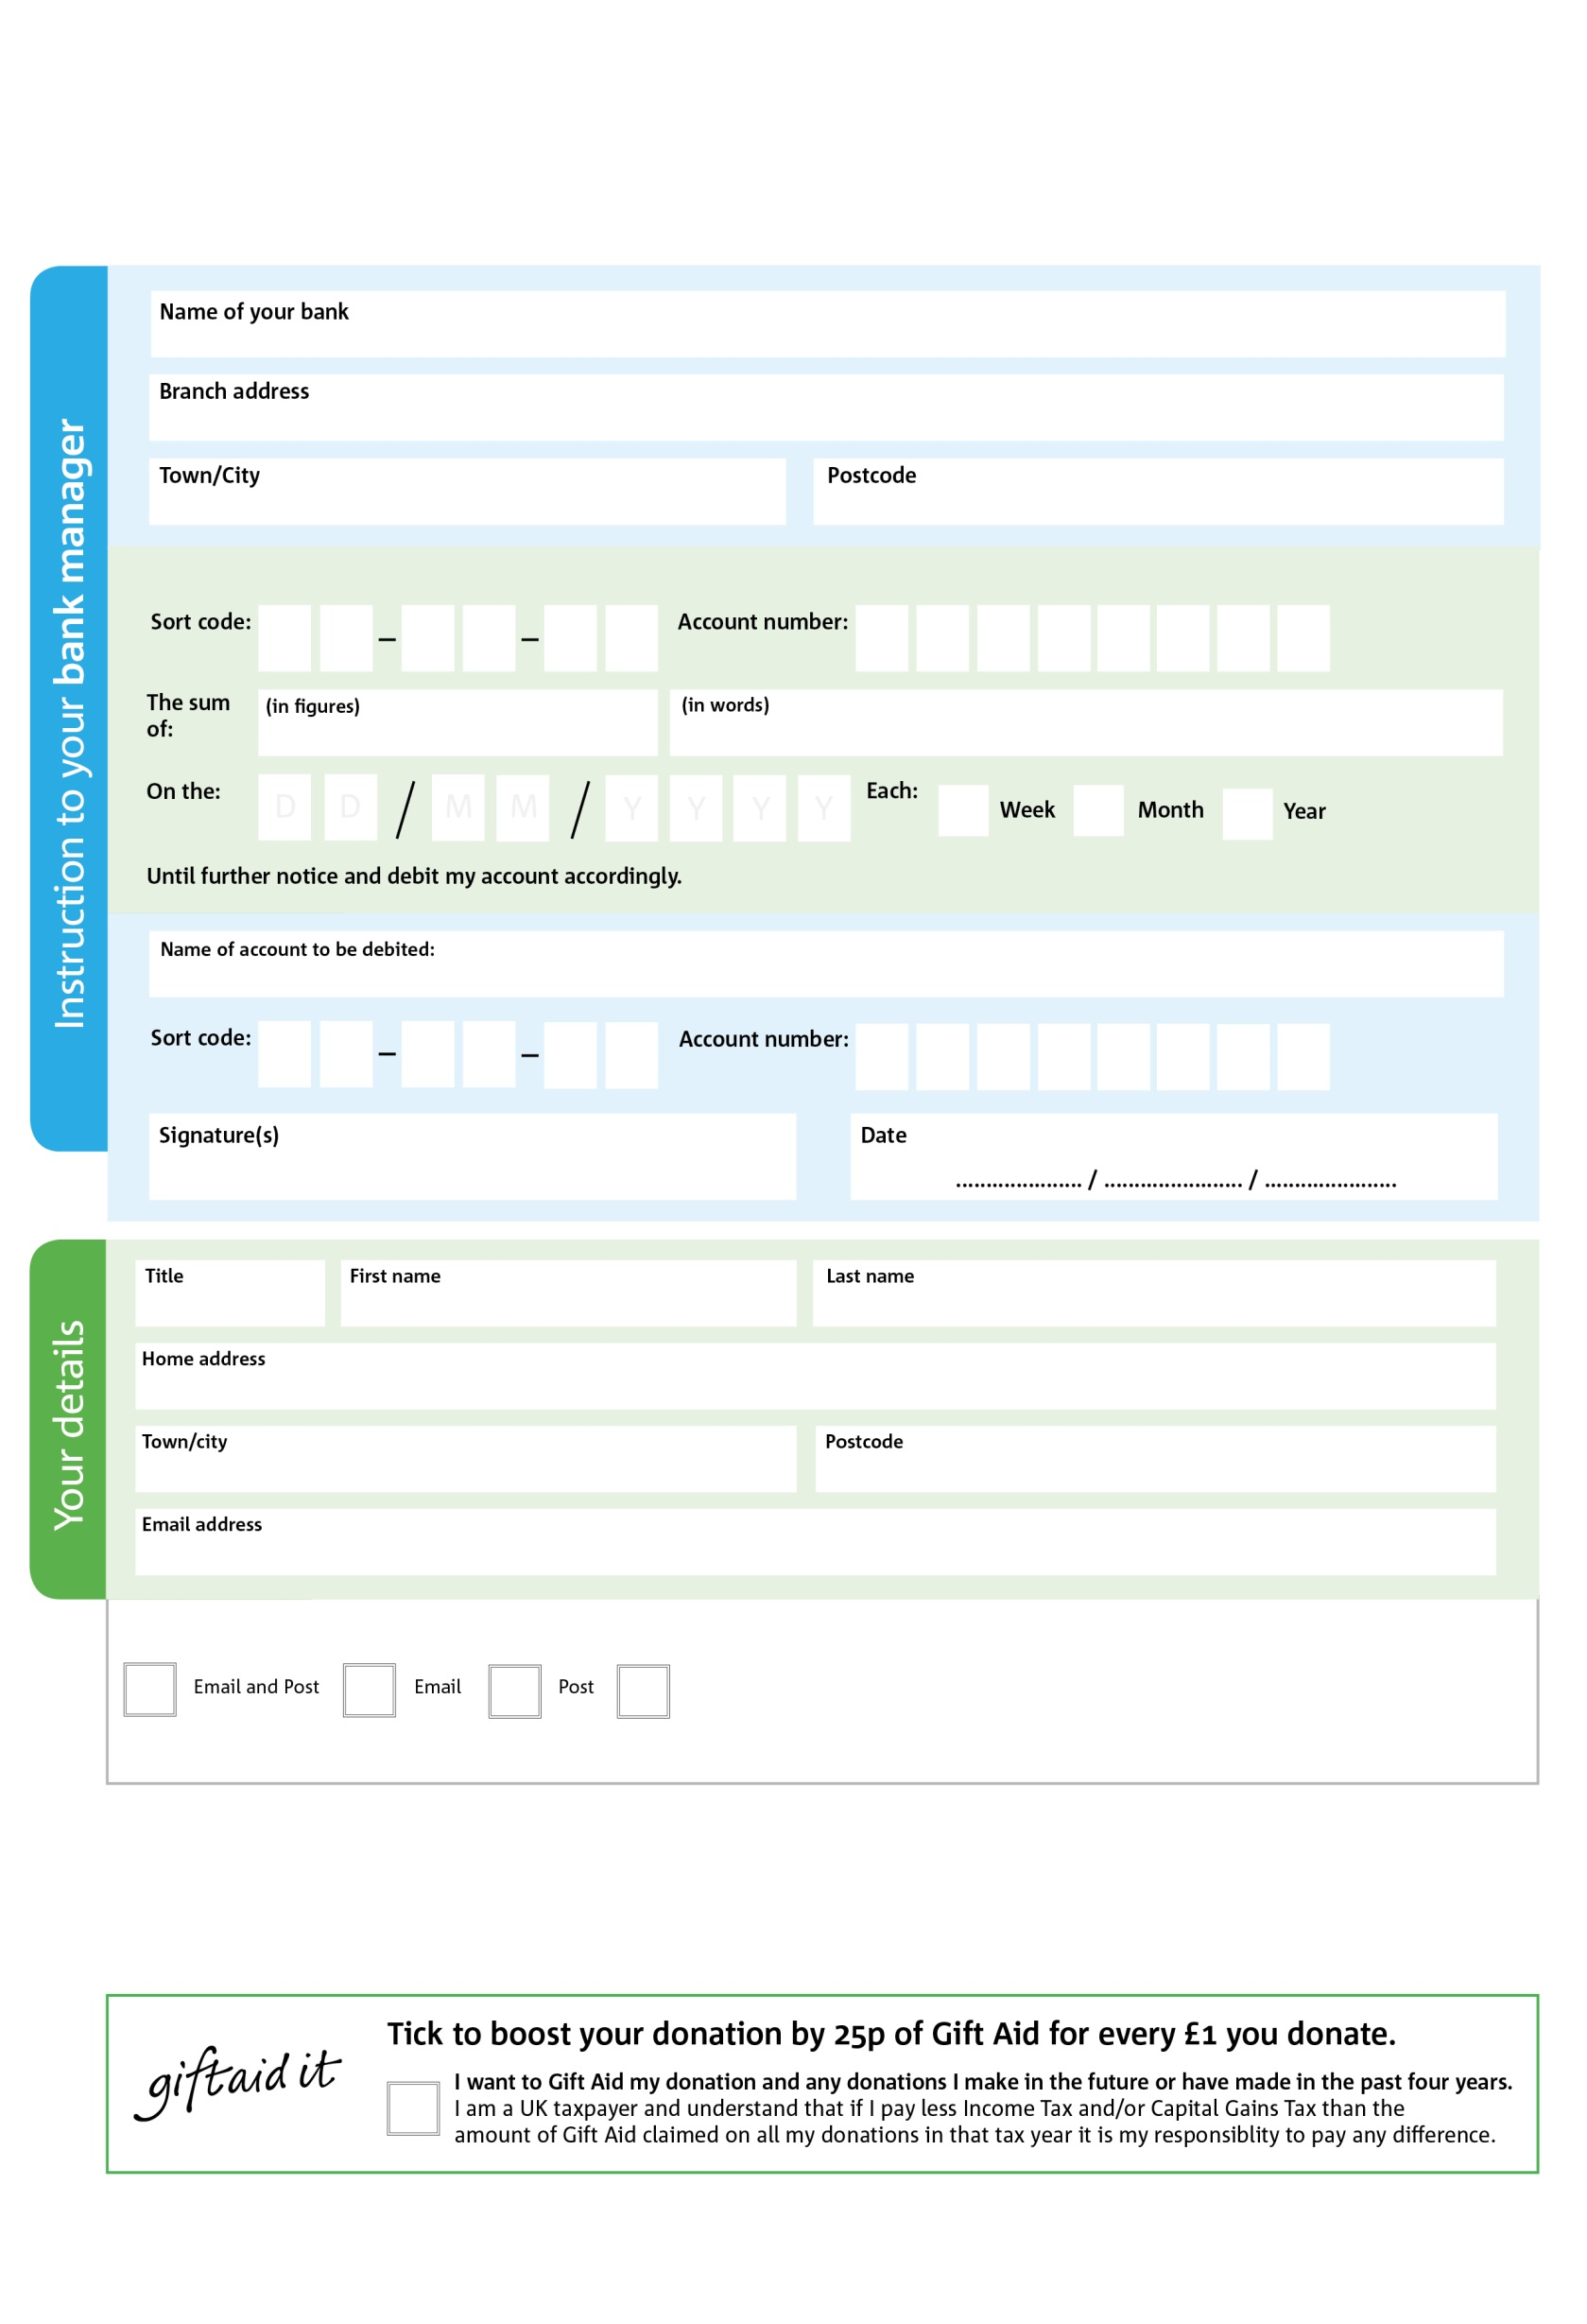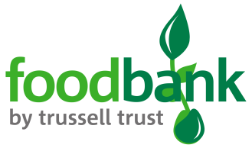

**Please pass this form onto the foodbank, using the foodbank’s address at the bottom, who will save a copy for their records.   
They will then send it onto your named bank or building society.**

**CUMBERNAULD FOODBANK**

**ST MONGO’S ROAD,**

**CUMBERNAULD G67 1QR**

1 6 1 0 7 4 0 4

Please pay Take Heart for The Nations (This is the Registered Charity and governing body of Cumbernauld Foodbank)

8 3 1 7 3 1

**Standing Order Mandate**

**Cumbernauld foodbank**

POSTAL ADDRESS: Cumbernauld Foodbank, 6 St Mungos Road, Cumbernauld, G67 1QR

Reg. Charity No: xxxxxx | Reg. in England & Wales

We would love to keep you up to date with information about Cumbernauld Foodbank. Please tick your preference:

You can change your preferences any time by contacting us on 07733057811 or emailing us at info@cumbernauld.foodbank.org.uk

I do not wish to receive future communications from Cumbernauld Foodbank

**Data protection**

*Our Foodbank is committed to protecting your privacy and will process your personal data in accordance with current Data Protection legislation. Cumbernauld Foodbank collects information to keep in touch with you and supply you with information relating to our work. To unsubscribe from our newsletter, send a message to the email address above with the word unsubscribe in the subject line. A full data privacy statement for financial donors is available from the foodbank on request.’*

You can change your preferences any time by contacting us on XXXXXXXXXXX or emailing us at XXXX@XXXXXXXXXX.foodbank.org.uk

I do not wish to receive future communications from XXXXXX Foodbank