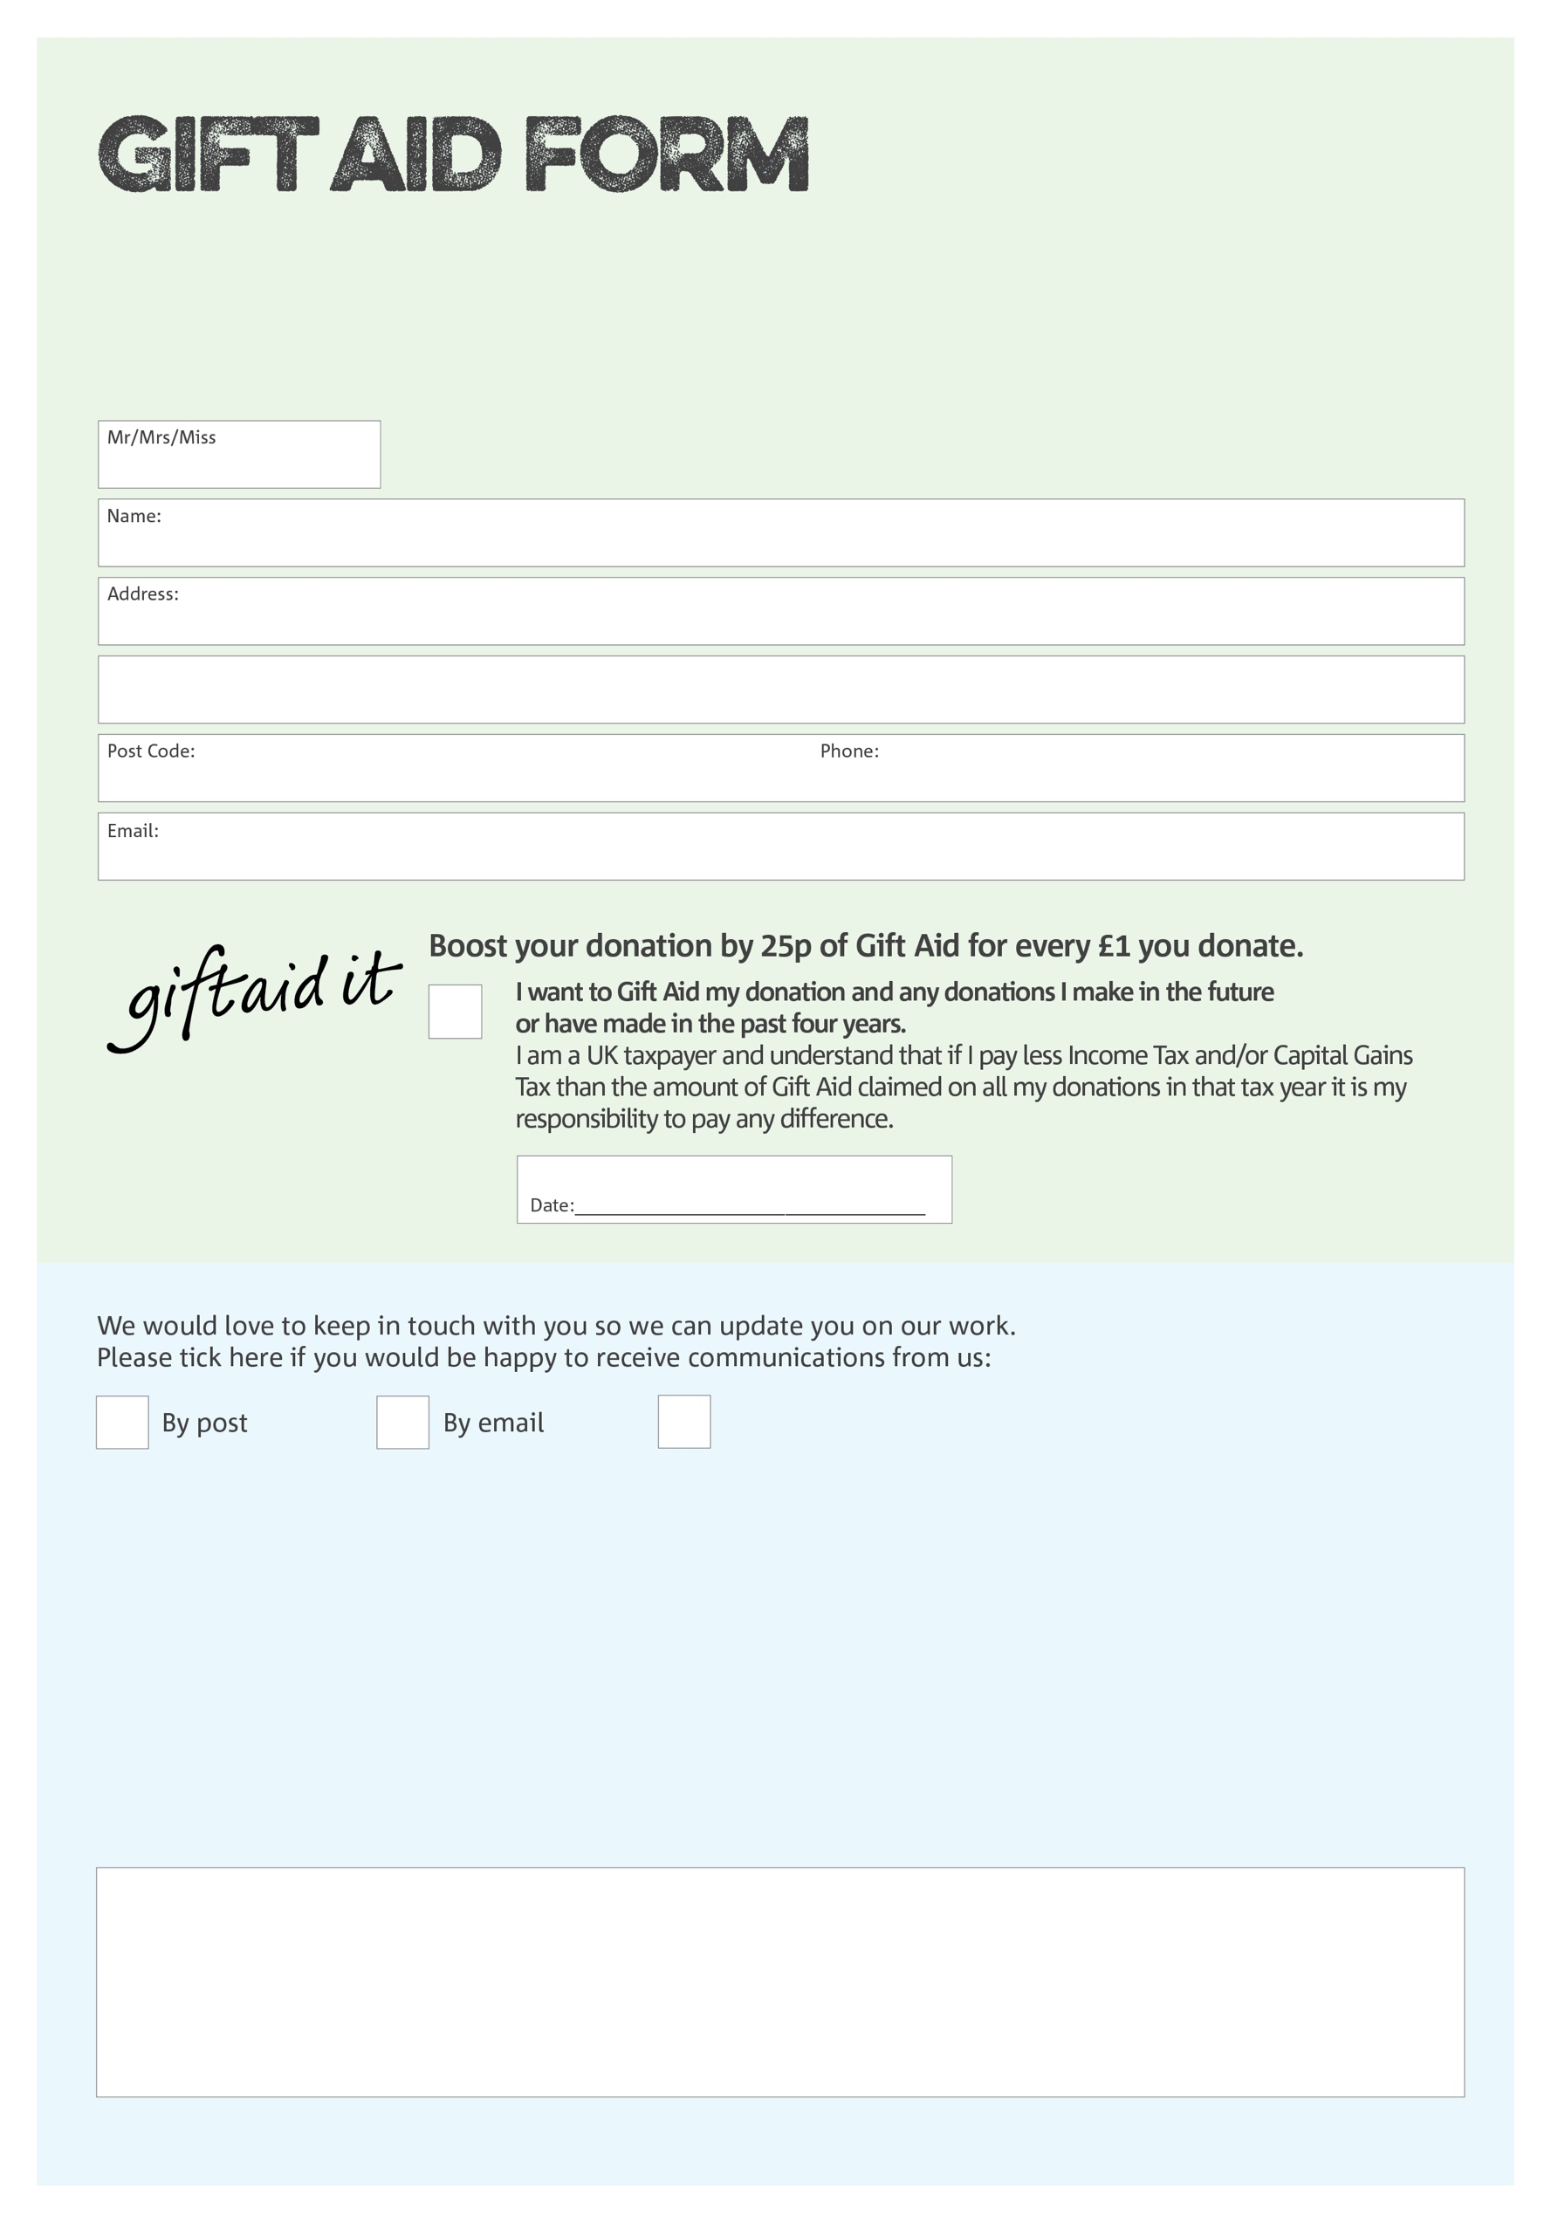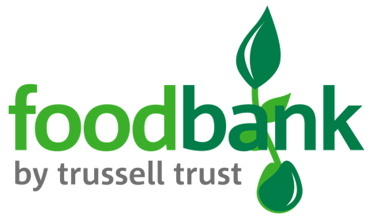

By filling in this form Cumbernauld Foodbank will receive an extra 25p for every £1 you give at no extra cost to you. Thank you!

Please note: Take Heart For The Nations is the registered charity under which the foodbank operates.

You can change your preferences any time by contacting us on 07733057811 or emailing us at

info@cumbernauld.foodbank.org.uk

We would love to know why you have chosen to donate to Cumbernauld Foodbank. If you would like to share your motivation let us know below:

**Data protection**

*'Cumbernauld Foodbank is committed to protecting your privacy and will process your personal data in accordance with current Data Protection legislation. Cumbernauld Foodbank collects information to keep in touch with you and supply you with information relating to our work. To unsubscribe from our newsletter, send a message to the email address above with the word unsubscribe in the subject line. A full data privacy statement for financial donors is available from the foodbank on request.’*

I do not wish to receive future communications from the Foodbank

Charity Number SC0421931. Registered in Scotland